GISMONDI 1754 ENDS THE YEAR WITH A +48%, CONFIRMING STRONG YEAR-ON-YEAR GROWTH

Genoa, 21 January 2022 – Gismondi 1754 (EGM ticker GIS), longstanding Genoese company that produces highest-end jewellery, communicates consolidated operating results for sales in the fourth quarter 2021 on a voluntary basis (figures not audited), divided by geographical area and sales channel.

In the fourth quarter 2021, Gismondi 1754 reported a total consolidated operating turnover of 3,996,320 euro, up +28.51%, compared to 3,109,850 euro in the fourth quarter 2020. The fourth quarter growth in sales - +595,777 euro - was mainly due to the Wholesale Europe channel (+135%) and the USA (+186%). Moreover, the performance of the St. Moritz shop (+1496%) should truly be noted. It mitigates the difficulties had by the shops in Portofino and Genoa, which suffer the location’s typical seasonal element in this stage, and by Milan, which has also paid a price for the forced closures of its mall location.

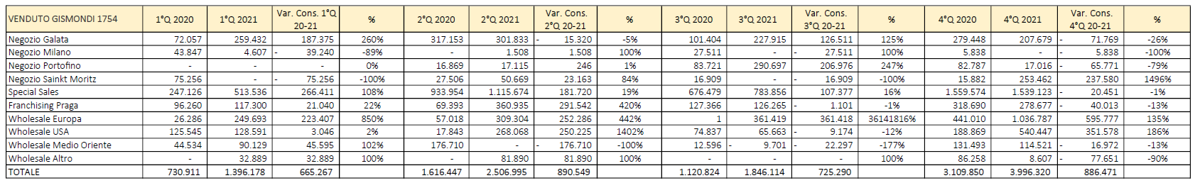

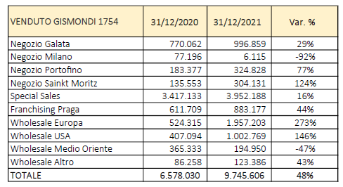

4Q results help create a financial picture for 2021, an extraordinary year, and the continual growth of Gismondi 1754. As a whole, it closes the 2021 12-month period with revenue of 9,745,606 euro, pulling off a +48% compared to 6,578,030 euro in 2020.

Analysing the data by sales channel over 12 months, shows that 2021 growth was pushed by the European Wholesale channel (+1,957,203 euro compared to 2020) and by Wholesale USA (+1,002,769 euro compared to 2020). The only channel to drop slightly was Wholesale Middle East, while waiting for new orders to get into full swing. For what concerns special sales - the Gismondi 1754 “custom-made” - 2021 closed with a +16%, recording sales for 3,952,188 euro. A result further enriched in the last week of the year, which realised special sales for over 1 million euro, also thanks to the e-commerce channel (please see the 11 January release).

On analysing revenue by geographical area, the turnover effect of the Italy area as at 31 December 2021 was 26% in the 4Q compared to 16% in the same period of 2020. Overall, Europe is worth about 53% of the Gismondi 1754 turnover, whereas the effect of other Countries remains stable, including Russia (5%) and others (13%).

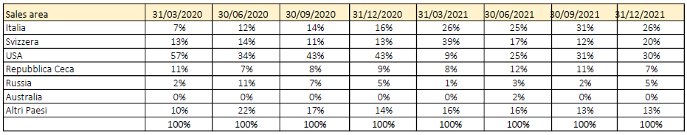

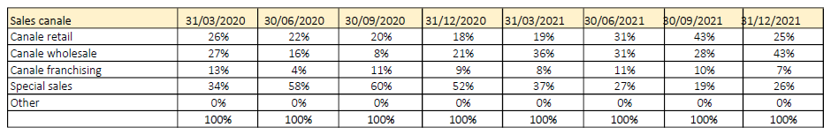

Massimo Gismondi, Ceo of Gismondi 1754, commented: “These are extraordinary results that certify Group and brand growth, despite the difficult economic period. We have reached almost +50% year-on-year growth and can see how all sales channels have performed and contributed positively to achieving these figures. A sign of the excellent job done by all segments and recognition by customers of the quality and care we put into creating each piece of jewellery”.

When presenting its figures, the Company always likes to remind us that the economic effects caused by the ongoing pandemic are evolving continuously, so the above represents the situation as at 31 December 2021. In order to provide the market with continuous, progressive information on the management trend, the Company will be communicating the economic and financial effects of COVID-19 emergency on its activities without delay, in compliance with EU Regulation 569/2014 (MAR).

About Gismondi 1754:
Handmade in Italy by Italians
Established in Genoa in 1754 with Giovan Battista Gismondi (supplier of Pope Pio VI and the Doria family), Gismondi 1754 - managed by Massimo Gismondi - has achieved a globally acknowledged excellence and competence in jewellery. Massimo Gismondi, known for considering jewels works of art, expresses centuries of craftsmanship and a rich history in his creations, matched with a contemporary style handing down a taste for beauty, a seven-generation company inheritance. The Company has been listed on the Euronext Growth Milan market of the Borsa Italiana (Italian Stock Exchange) since 18 December 2019.

Gismondi1754 S.p.A.
Via San Vincenzo 51/1, Genoa
Contact for Investors: Marcello Lacedra
Tel: +39 010-4074142 Email: investor.relations@gismondi1754.com

Euronext Growth Advisor
EnVent Capital Markets Ltd
London, in Berkeley Square, 42, W1J54W,
Email: lperconti@enventcapitalmarkets.uk
Tel +39 06 896841

Press Office
Spriano Communication & Partners
Via Santa Radegonda, 16 Milan
Matteo Russo
Mob: +39 347 9834 881
mrusso@sprianocommunication.com
Cristina Tronconi
Mob: +39 346 0477 901
ctronconi@sprianocommunication.com

GENOA – MILAN – PORTOFINO – ST. MORITZ – PRAGUE – ST. BARTH – USA – SAINT PETERSBURG

